Student’s name | …………………………………………………….…… | Grade | 1
Subject | Computer | Week No. | 15
Lesson Title | Creating Digital Art | Unit
Worksheet No. ( 15 ) (Answer)

Question A: write the correct name of each part

Pencil | Toolbar | Hard eraser | Paintbrush
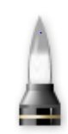
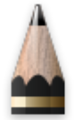


Hard eraser
Pencil
Paintbrush
Toolbar
Good Luck

